Sample format for HW4 and HW5

Instructions:

- Copy each question to a word document
- Under each question, copy paste the code from SQL work bench.
- After the code include a screenshot of your result
- Make sure everything is clearly visible.

- Write an SQL code to display all records from the D_T

Select * from S_Customer_T;

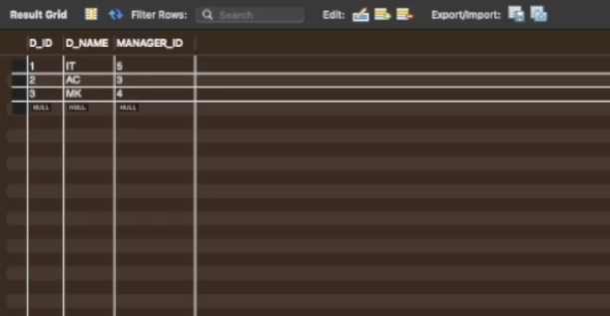

- Write SQL code to display Name from D_T table where D_ID = 1

Select D_NAME from D_T where D_ID = 1 ;

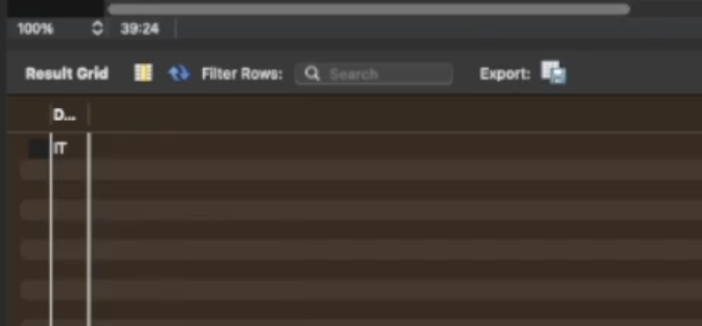

- Question

Copy-paste the Code (Ctrl C + Ctrl V)

Add screenshot of result

- Question

Copy-paste the Code (Ctrl C + Ctrl V)

Add screenshot of result

- Question

Copy-paste the Code (Ctrl C + Ctrl V)

Add screenshot of result

